Qudus Olalekan

Codar tech africa

**DASHBOARD IN EXCEL**

**Step-by-Step Approach**

**Learning Objectives**

By the end of this session, learners will be able to:

* Prepare and format data using filters and table styles.
* Create pivot tables to calculate key metrics such as total sales and profit.
* Design a professional dashboard layout with shapes, icons, and titles.
* Insert and customize various chart types (column, bar, and line).
* Link pivot table data dynamically using formulas like GETPIVOTDATA.
* Apply slicers for interactive filtering across multiple pivot tables.
* Use consistent formatting, colors, and alignment to improve readability.
* Integrate all elements into a dynamic, refreshable dashboard that provides clear insights.

**Class 6**

**📊 How to Create a Sales Dashboard in Excel**

**1️⃣ Overview of the Dashboard**

The Sales and Profit Dashboard is designed to provide **clear insights into business performance**, displaying key metrics such as:

* Total Sales and Total Units
* Product Sales
* Regional Sales
* Monthly Sales Trends

**2️⃣ Step 1: Prepare the Data**

**a. Format the Data Table:**

1. Select the entire dataset.
2. Go to **Home → Format as Table** and choose a design (or use **Cntr** **T)**.
3. Freeze the top row:
   * Go to **View → Freeze Panes → Freeze Top Row**.

**3️⃣ Step 2: Create Sheets**

* Create two new sheets:
  + **Pivot Tables Sheet** (for summarizing data).
  + **Dashboard Sheet** (for the final layout).
* How to create new sheets:
* Look at the bottom of the window, next to your existing sheet tabs, and click the **“+” icon** (labeled *New Sheet*) to add a new sheet (or use **Shift F11**).

**4️⃣ Step 3: Build Pivot Tables**

1. **Key Metrics (Sales & Units)**
2. Select the dataset → **Insert → PivotTable** (by the extreme left) → Place it in the **Pivot Table Sheet** (by selecting “existing worksheet” in the pop-up and then, clicking the name of the worksheet below to insert it in the box).
3. Drag **Sales** into **Values** → Sum of Sales.
4. Copy the Pivot Table, paste below it, and replace Sales with **Unit**.

**b. Product Sales**

1. Copy down the pivot table.
2. Drag **Item** to **Rows** and **Sales** to **Values**.

**c. Regional Sales**

1. Copy down the pivot table.
2. Drag **Region** to **Rows** and **Sales** to **Values**.

**d. Monthly Sales Trend**

1. Copy down the Pivot Table.
2. Drag **Date** to **Rows** and uncheck all date breakdowns, including **Date** itself, except the **month** from the **hierarchy**.
3. Drag **Sales** to **Values**.
4. Format values: **Currency, 0 decimals**.

**5️⃣ Step 4: Design the Dashboard Layout**

1. Go to **Dashboard Sheet**.
2. Turn off gridlines: **View → Uncheck Gridlines**.
3. Insert Shapes:
   * Use **Insert → Shapes → Rounded Rectangle** for sections.
   * Remove outline, set fill color (you will see all these options in the **shape format** tab that appears once you click on the shape you want to format).

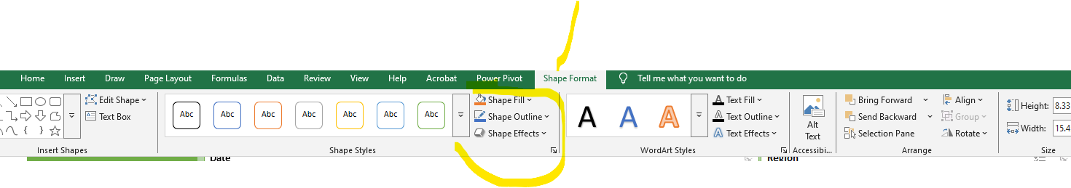

**6️⃣ Step 5: Add Dashboard Title & Icons**

1. Insert a **Text Box** → Type: *"Sales Dashboard"*.
2. Format the title as you like (font size, bold, color).
3. **Insert Icons**:
   * Go to **Insert → Icons (or Images)**.
   * Add icons (💵 Dollar sign for sales, 📈 Graph for unit, etc.).

**7️⃣ Step 6: Link Key Metrics**

1. Duplicate your **KPI** values dynamically (Total Sales and Total Units):

* Locate the KPI value in the Pivot Table.
* In a blank nearby cell, for instance, any blank cell just to the right of the Pivot Table, type **=GETPIVOTDATA** and select the cell that holds the KPI value

*This ensures the KPI is linked dynamically to the Pivot Table and will update automatically when the data refreshes.*

1. Format the Linked Value:
   * Apply number formatting (e.g., currency, comma separator) to make it display cleanly.
   * This step ensures the value looks exactly how you want it in the dashboard.
2. Insert **Text Boxes** in your **dashboard** where you would like to place your Total Sales and Total Units.
   * Go to **Insert**, then **shape**, and select **Text Box**. Go to the dashboard sheet and draw the text box where you want the KPI displayed.
3. Link the Text Box to the KPI Cell
   * Click the text box, then in the formula bar type **=**
   * Navigate to the pivot sheet and click the cell where the duplicated value is located.
   * Press **Enter**. The text box will now display the KPI dynamically.
4. Style the Text Box
   * Adjust font size, color, and alignment to match your dashboard design.

**8️⃣ Step 7: Insert Charts**

Create charts from pivot tables:

* **Products Sales** → Bar Chart.
* **Regional Sales** → Column Chart.
* **Monthly Sales** → Line Chart.

Click on the pivot table you want to create chart for and the **PivotTable Analyze** tab will appear

Click on the tab, and select **PivotChart** on the right side of the window.

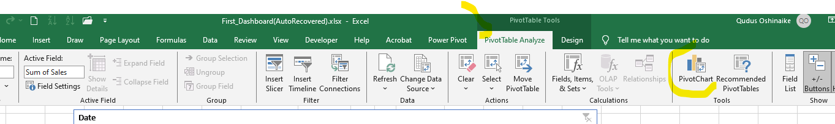

Format charts:

* No background outline.
* Apply brand colors.
* Add **titles, data labels**, and adjust font sizes (You will see different things you can do to your charts immediately you select it).

**9️⃣ Step 8: Add Slicers (Filters) and Timeline**

1. Go to Pivot Table sheet → **Insert → Slicer**.
2. Add filters: **Region, and Product,**
3. Add Timeline (It is just beside **Slicer**)
4. Customize slicer and timeline design (colors, borders, font).
5. Link slicers and timeline to all pivot tables (**Right-click slicer → Report Connections**).

**🔟 Step 9: Final Touches**

* Apply consistent color themes.
* Adjust alignment and spacing.

**✅ End Result**

You now have a fully interactive **Sales Dashboard in Excel** with:

* Automated key metrics
* Interactive charts
* Slicers for filtering
* A clean, professional layout